**PROTRACTOR TOOL INSTALLATION USER MANUAL**

To setup protractor, we need to install three things

1. Node.js
2. Protractor
3. Selenium Webdriver

### Node.js Installation

**Step 1:** Download the Node.js software and Run the installer

**Step 2:** Follow the prompts in the installer (Accept the license agreement, click the NEXT button a bunch of times and accept the default installation settings).

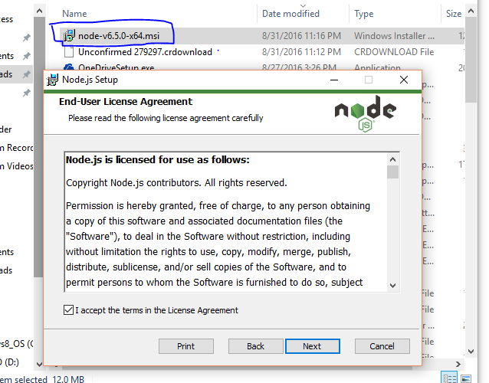

**Step 3:** Select the npm package manager feature.

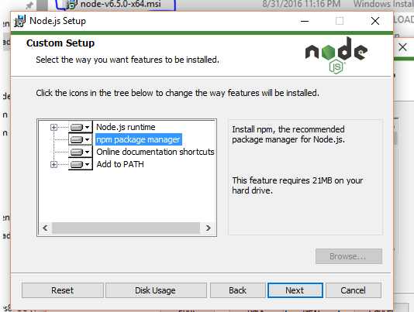

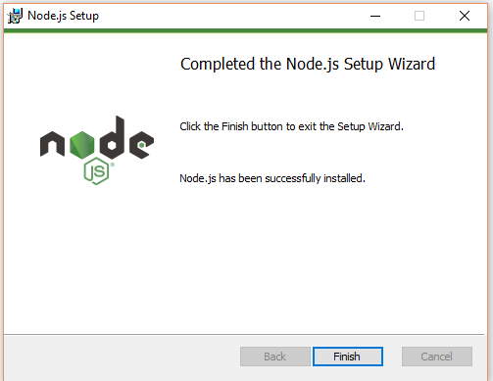

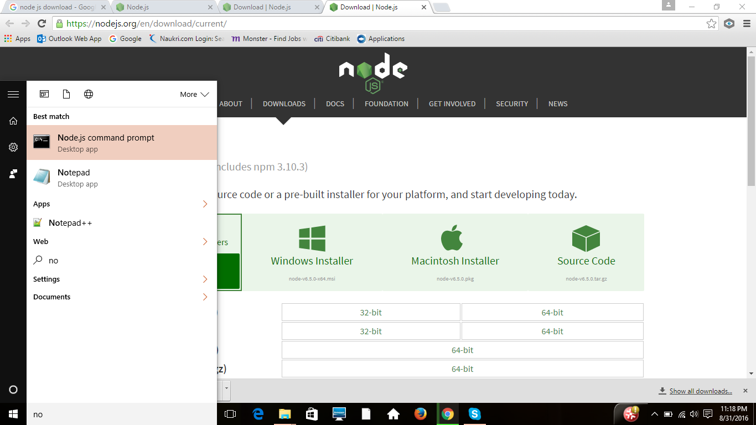

**Step 4:** To verify your installation, Please type‘**node –v’/’node --version’**in the command prompt which displays you the node version that is installed.

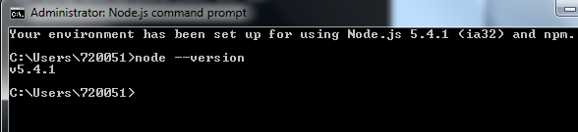

### PROTRACTOR Installation

Below are the steps for installation:

**Step 1:**To install globally, please type the command” **npm install –g protractor**” in command prompt.

The above command will install protractor and make it available globally.

Path may look like C:\Users\User_name\AppData\Roaming

**Note**: if you are not able to view the AppData folder, request you to view the hidden folders.

C:\Users\ User_name\AppData\Roaming>npm install -g protractor

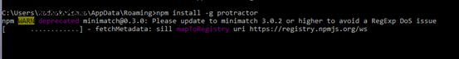

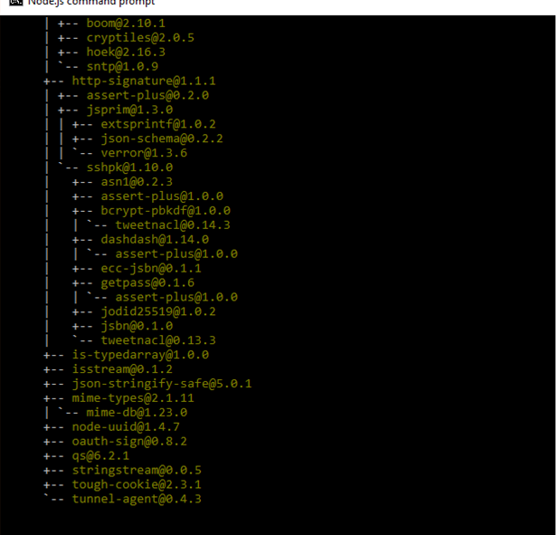

**Step 2:** Once that is done, confirm by typing **'protractor --version'** in the command prompt which will show you the protractor version that is installed.

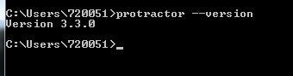

**Step 3:**To update the selenium webdriver, please type the command **'webdriver-manager update'** in command prompt.

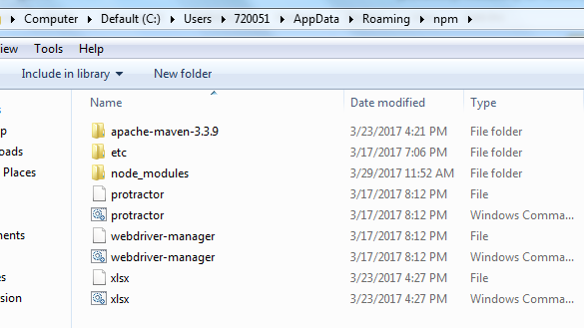

**Step 4:**Now start up a server, please type the command **'webdriver-manager start'** in command prompt.

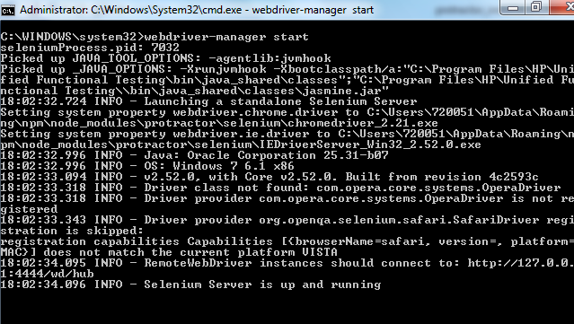

**Step 5:**To Install Jasmine HTML reports, Open other nodejs command prompt and run the below cmd

**npm install protractor-jasmine2-html-reporter**

### Environment variables Configuration:

Set Environment variables as mentioned below

* **SYSTEM VARIABLES:-**

**JAVA_HOME** = C:\Program Files\Java\jdk1.8.0_92

**NODE_PATH** = C:\Users\jt\AppData\Roaming\npm\node_modules

**PATH** =C:\Program Files\nodejs\node_modules\npm;C:\Program Files\Java\jdk1.8.0_92\bin;C:\Program Files\Java\jre1.8.0_92\bin;C:\Program Files\nodejs\